**How to Save All Distribution List Members In txt File**

1. Open Outlook and start a new email.
2. Click **To** button and select the distribution list you need to save in TXT.
3. Click the plus **+** sign to expand the members.  
   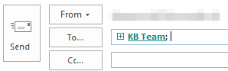
4. Select all members of the distribution list and copy them.  
   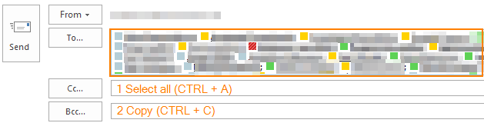
5. You can close the email as you do not need it anymore.
6. Navigate to *Home > New items > More items > Contact group*.  
   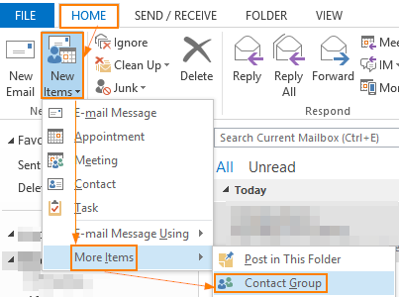
7. In the Contact group, go to *Add members > From Address book*.  
   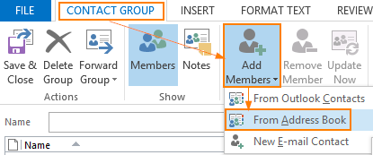
8. Paste the names and email addresses into the **Members** field.  
   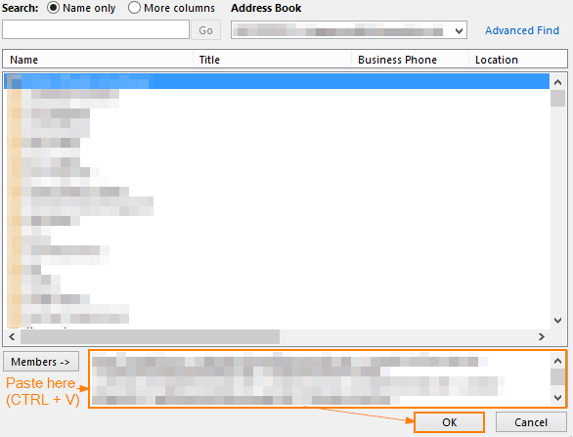
9. Go to *File > Save as* and save your contact group as a TXT file.  
   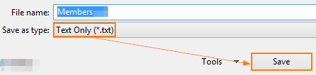
10. Open the txt file you just created and Replace the first lines from it, as it is showing in the below image.

